## Exercise 20: Flag of [your choice!]

## Choose any country and design their flag using Python Graphics!

Some options are given below, though you can pick any country you’d like. Choose one that will be a good challenge for you or ask your teacher which flag you should create. You may want to avoid flags that contain images.

Your flag should fill a canvas with a width of 400 and a height of 300. More details on flag shape dimensions can usually be found by googling the country flag.

**Beginner:**

* Germany  
  
* Nigeria  
  
* Colombia  
  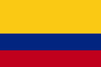

**Intermediate:**

* Sweden  
  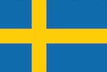
* Switzerland  
  

**Advanced:**

* Iceland  
  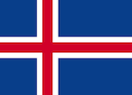
* Czech Republic  
  
* Bahamas  
  
* Greece  
  
* North Macedonia  
  